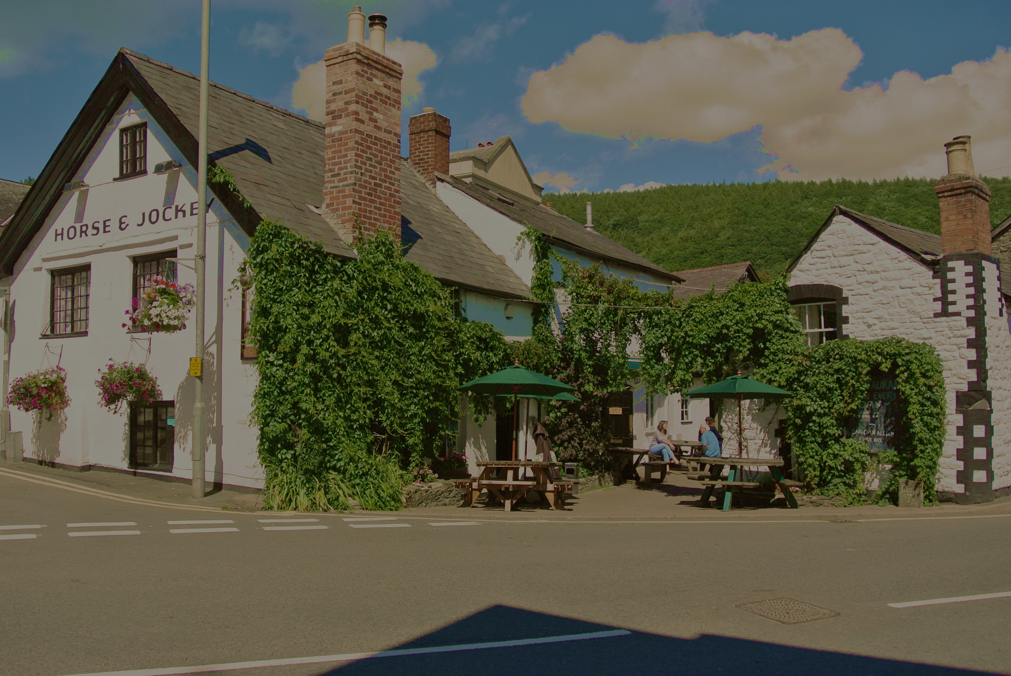
Like many, we have been closely following updates from the government. We would like to reassure all of our customers that we are taking every precaution to protect our customers and our staff during the current coronavirus situation.

We have increased our daily hygiene and cleaning protocols in the public areas and continue with our high standards of food and hand hygiene.

At the moment the pub will stay open and we hope to continue to do so. We will keep monitoring the situation and will update everyone, as soon as anything changes.

If you have to cancel your reservation with us, please let us know as soon as possible to help us prepare for trade. We do ask, if you or a family member have presented with symptoms of covid 19 that you do not visit us, and self-isolate as per government guidelines.

In the coming weeks, we may need to adopt a smaller, but just as delicious menu. For now, we have decided to close the restaurant at lunch times, except for Sunday Lunch. Food is served in the Bar area as normal.

We are grateful to all our loyal customers for the support that you give to us.
Stay safe and most importantly stay well.

Wouter, Stephanie and the Jockey Team

